




WEBSITE & DESIGN DEVELOPMENT

Website Design Document
Huda AL-Falah
22220033
Section 3
Dr. Hana AL-Rashed




Website Goal

The "La Prima" website exists to deliver a unified platform that offers tailored dress customization alongside advanced service delivery with enhanced user interaction. La Primaicits website exists as a tool for customers who want unique dress design experiences and quick booking functionalities with comprehensive user navigation that matches both designer propositions and customer flexibility needs.

Main objective details:

Custom dress design:

Users have the ability through the website platform to build tailored dress designs according to their personal selection. The platform features a selection tool for customers to customize fabric type and pick colors alongside length decisions and specific details about sleeves and neck patterns. Users have an option to upload their designs which the website team evaluates for future modifications.

Users should create designs reflecting their personal style and individual requirements through an interface which suits their preferences.

Booking appointments with designers:

Users can book scheduled meetings with designers through this website's fully integrated service which enables discussions about designs and request evaluation. By using this system users can create designs which match customer expectations exactly.

Website reservations are confirmed instantly providing users access to a reminder system to manage scheduled appointments.

Excellent and responsive user experience:

The website design detects all device types including mobile phones and tablets along with computers to deliver seamless experiences for customers.

The website provides a clutter-free interface that lets customers move easily from section to section.

Enhancing the visual identity of the brand:

Through its website "La Prima" works to position itself as a unique brand in fashion design space. The interface delivers advanced features that present the brand image through refined sophistication and professional integrity.

Additional goals:

Support the user experience with distinctive interactions:

Users can interact with high-quality image displays while benefiting from intuitive visual design customization tools.

Providing flexible design options:

Users can adjust their design choices by altering sleeve types as well as dress length and may also add features such as embroidery functions.

Ease of communication:

The website provides both instant contact forms together with live chat options through which visitors can submit inquiries and change their orders.

The goal of "La Prima" is to become the initial platform for customers who want personalized dress customization. The system aims to deliver a straightforward and accommodating interaction platform that matches user intentions while providing higher value than customers expect.

The site provides services to both designer and customers to match user needs through an intuitive interface that delivers dress customization freedom. Users benefit from this e-commerce site because it provides they with free tools to connect with the designer through its communication facilities.

Scope

La Prima delivers multiple design scenarios along with personalized operational areas to let users build custom dresses based on their individual specifications. Users can easily customize dresses through the site's interface by selecting fabric types from silk to cotton and determining colors and fine measurements like sleeves while the system also accepts personalized design uploads for aesthetic review and production.
Booking designers for appointments to discuss design details functions right within their system. Customers get immediate confirmation after selecting appointment times that match their schedule and they have easy access to reservation modification and cancellation features.
The website utilizes a flexible design structure which delivers optimal functionality across all screen sizes therefore users experience convenience no matter what device they choose to use. Users can easily browse site pages including dress customization and appointment booking and confirmation interfaces because of the straightforward layout. The interface allows users to interact with it by displaying warning messages when incorrect data entries occur along with easily accessible contact forms for support team or designer communication. Customers can view the ready-made dress page that presents high-resolution images along with detailed explanations that demonstrate the product's superior quality.

Requirements

Outline of Functional Requirements
Users can personalize dresses through basic website functions while managing designs while maintaining secure account authentication on La Prima. The system functions operate under design criteria that combine simple usage alongside seamless integration.

Requirement 1: Dress Customization
Explanation of the requirement:
Users can personalize dress designs through the website by selecting their favorite options. Through the website users can create their design by selecting fabric types alongside colors and lengths while adding supplemental features. Designs saved through the process are stored for review on the Design Card page.

How to fulfill the requirement through the website pages:

Design Dress Page:

These pages present selection lists to guide users through fabric choices and color and length preferences.
Users can upload their designs through dedicated upload fields.

Users can use the "Save Design" button to store their creations on the Design Card section.

Submission Page:

A success notification appears after users save their designs.

The site features buttons that let users visit their homepage or redesign their pages.
Requirement 2: Design previews are managed through the Design Card interface.
Requirement explanation:
Users on the Design Card page access their saved designs directly and possess the capability to edit or remove any previous work from the collection.

How to fulfill the requirement via site pages:

Design Card page:
The user's saved designs display as a list with fabric details and color selection and length information.
Provides options such as:
The user can access full design details by selecting "View Design."
Selecting "Edit Design" from this page redirects users to design customization.
Users can execute the action "Delete Design" to eliminate designs from their list.
Requirement 3: Login Page
Requirement explanation:
Users can connect to their personal account through a secure page which enables them to handle their designs. Users need to provide their correct email and password details to access authentication.

Sitemap

Organized by hierarchical order the Site Map reveals how all components connect through transparent navigation pathways. Through page organization and relationship management the Site Map helps users and developers grasp the website's structure and operational design.

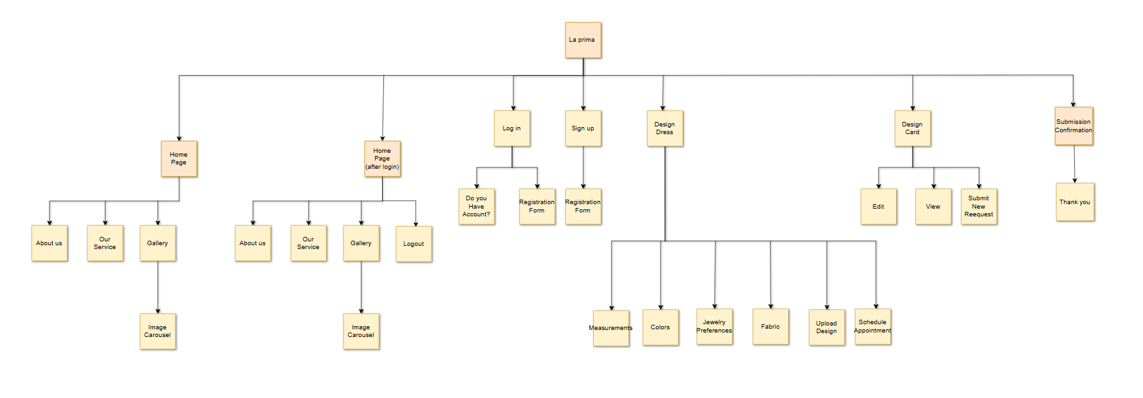
The purpose of the Site Map is to:
The document provides complete details about the website layout.
Help the development team develop all needed web pages together with required features.
Users will have a pleasant experience when they operate the platform because you have made navigation elements easy to understand and smooth to use.
Key Sections in the Site Map:
Homepage:
Divided into two states:
Before Login: Features options like Login and Sign Up.
After Login: Throughout the site System enables registered users to log out and obtain personalized website elements.
Main sections:
About Us: Displays information about the website or company.
Our Services: Highlights the available services.
Gallery: Showcases images in a carousel format.
Login and Sign-Up Pages:
When users log in new users can create an account through the Sign-Up page as they complete a registration form.
Customization Page (Design Dress):
Platform users can transform orders through measurement selection and material choices alongside colour options and design uploads and appointment reservation.

User Dashboard (Design Card):
Through this web page users can make profile modifications alongside looking at past product demands and sending fresh ones.
Submission Confirmation Page:
Submissions trigger a thank-you notification whenever users finish completing requests or forms.
Logout:
The system allows users to perform account logouts through a secure method
The Site Map allows users to find website features seamlessly which creates an easygoing user experience.

Wireframes
Wireframes

Website and Phone Design:
Home page1:
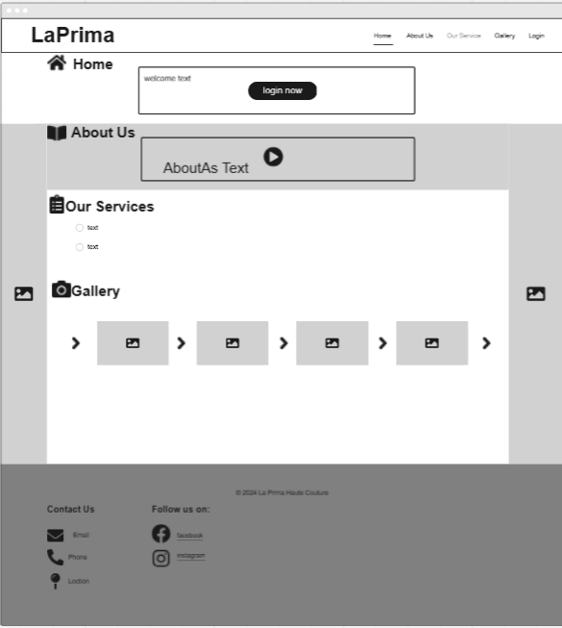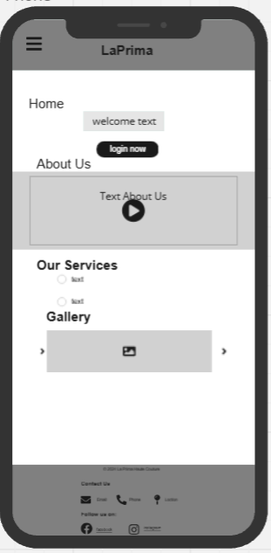
LogIn page:
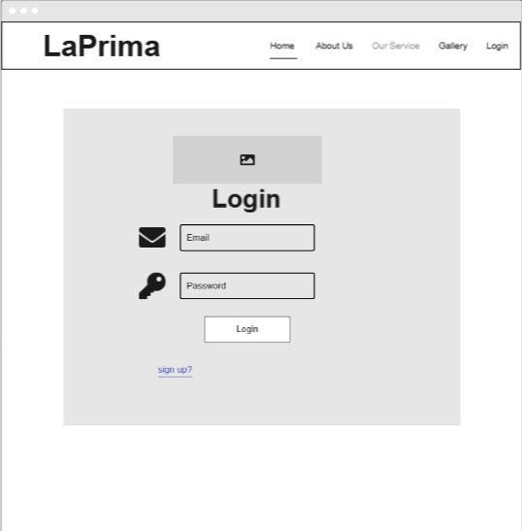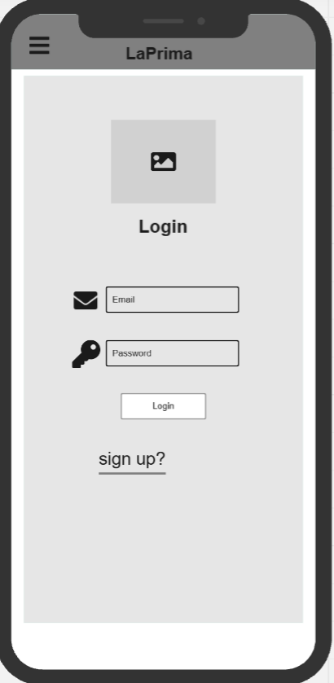
Sign Up Page:
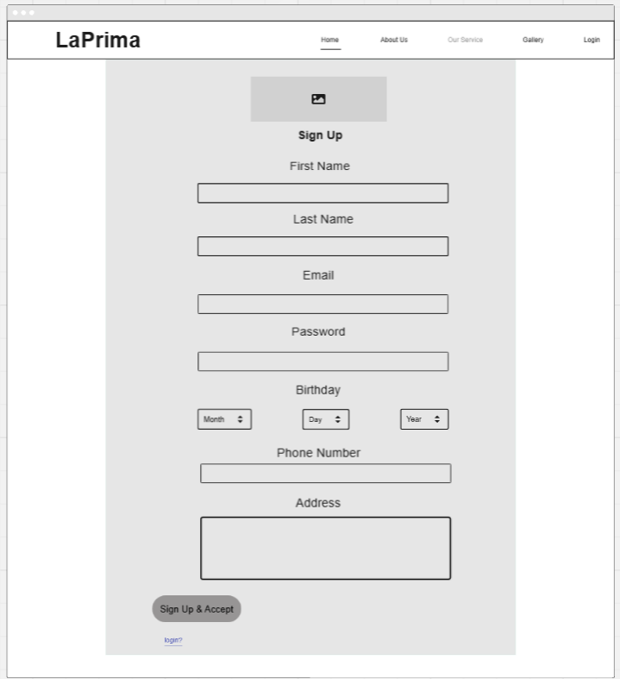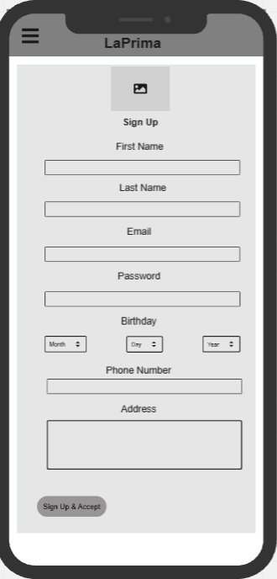

Page home after login:
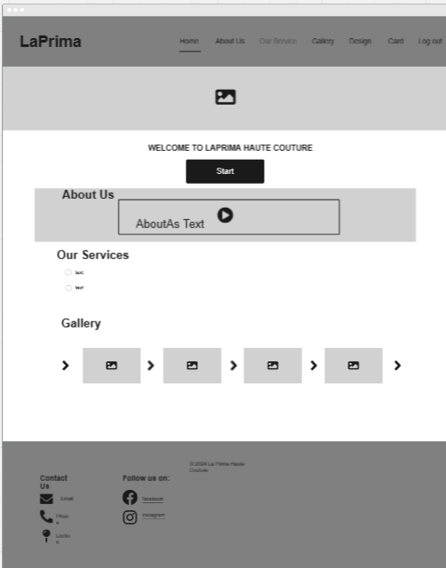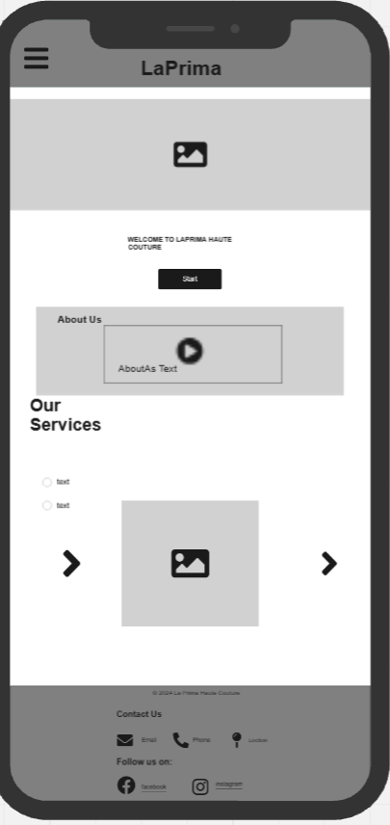

Design Dress Page:
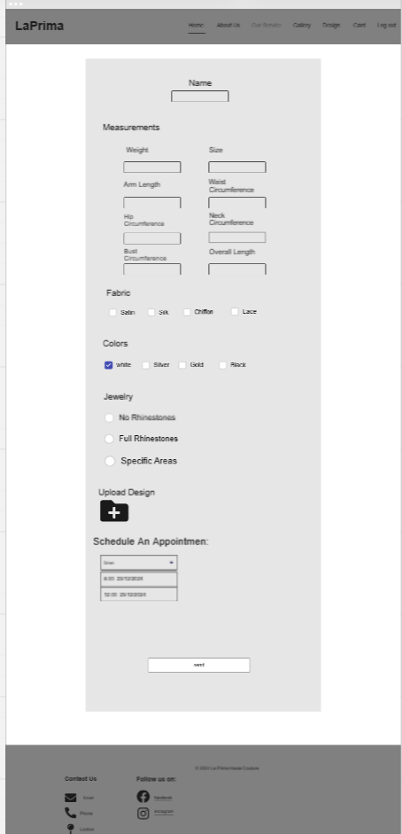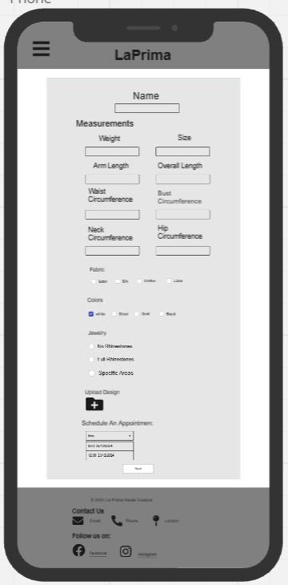

Dress Card Page:
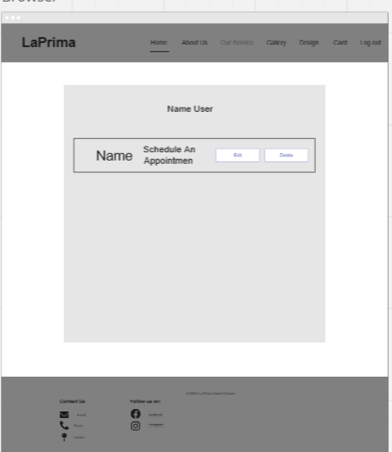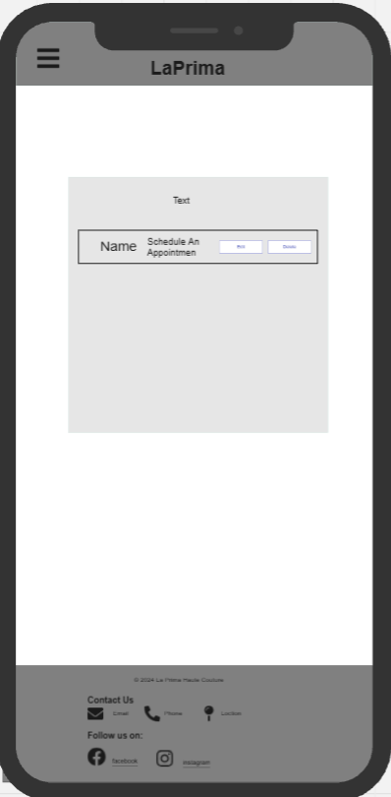

Submitted page:
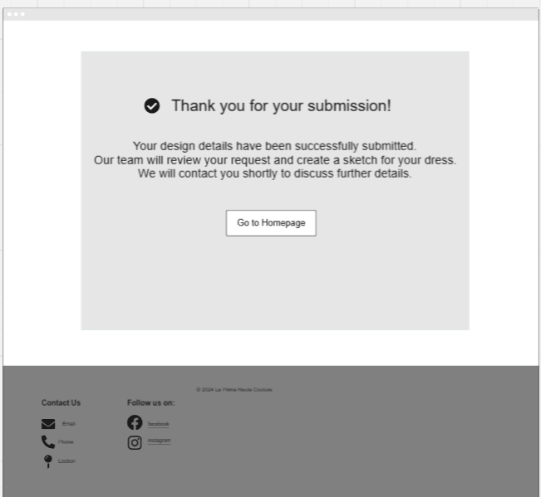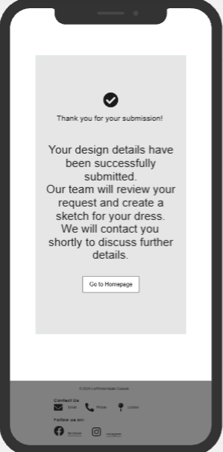

Website Wireframes
The visual presentation called wireframes marks the starting point for building website structures and arranging website elements. Wireframes provide developers along with stakeholders visual direction about interface design to help them visualize both component placement and complete UX interactions.
The fundamental reason to develop wireframes centers around discovering a page's most important organizational fit for key components which include navigation menus buttons forms and images. The first visual depiction of plans through wireframes reinforces user convenience by providing clear layouts to help teknorapide guide website development works toward specified objectives.
The platform Miro enabled the generation of wireframes for our project. The interactive features of Miro's platform helped users quickly restructure their design choices while simultaneously working towards both planning and execution of the website's structure.

Each wireframe corresponds to a page or feature in the website:

The Home Page:
Is divided into two versions. The first version is for users who are not logged in, featuring a "Login" button and sections like "About Us," "Our Services," and "Gallery," which includes an image carousel. The second version, displayed after login, replaces the "Login" button with "Logout" and provides additional navigation options for registered users.

The Login Page:
Provides fields for users to enter their email and password, along with a "Sign Up?" link for new users. It’s designed to be simple and user-friendly, ensuring smooth access to accounts.

The Sign-Up Page:
Contains a detailed registration form. Users can input their first name, last name, email, password, date of birth, and phone number. This page ensures that new users can create accounts effortlessly.

The Design Dress Page:
Offers users the ability to customize their orders. This includes inputting measurements like weight and size, selecting fabric types and colors, specifying jewelry preferences, uploading custom designs, and scheduling appointments.

The Design Card Page:
Functions as a user dashboard. It allows users to edit existing designs, view submitted requests, and start new submissions, offering full control over their customization projects.

The Submission Page:
Confirms the completion of a user's request. It includes a thank-you message and a "Go to Homepage" button to redirect users after submission.

Each wireframe is directly connected to the Site Map. For example, the "Customization" section outlined in the Site Map is represented visually through the Design Dress Page wireframe, showing detailed options for measurements, fabric, and scheduling. Similarly, the Login and Sign-Up Pages in the Site Map are reflected in simple, functional designs in the wireframes.
The website structure requires proper alignment of user needs through wireframe tools. Wireframes help keep projects focused and become an efficient design model which guarantees page consistency throughout all stages of development. Wireframes function as the critical bridge between design fundamentals and active website construction through which successful platforms develop.

